Installing Dradis from Git

If your answer is not here the [Community Forums](https://discuss.dradisframework.org/) are your best bet.

Dependencies

**Kali Linux dependencies**: see the [dependencies section](https://dradisframework.com/ce/documentation/install_kali.html#dependencies) of the Installing Dradis on Kali Linux guide.

Video Tutorial

Getting Started

1. Head over to the [Dradis Framework repo](https://github.com/dradis/dradis-ce) on GitHub.
2. On your local system, run the following in your command line:
3. $ git clone https://github.com/dradis/dradis-ce.git

$ cd dradis-ce/

1. Run the following in your command line:

$ ./bin/setup

Setting up the app

1. Once you've completed the steps above, fire up the server by running the following in your command line:

$ ./bin/rails server

1. Point your browser to: [http://localhost:3000](http://localhost:3000/)
2. Configure the shared password by entering it and confirming it:

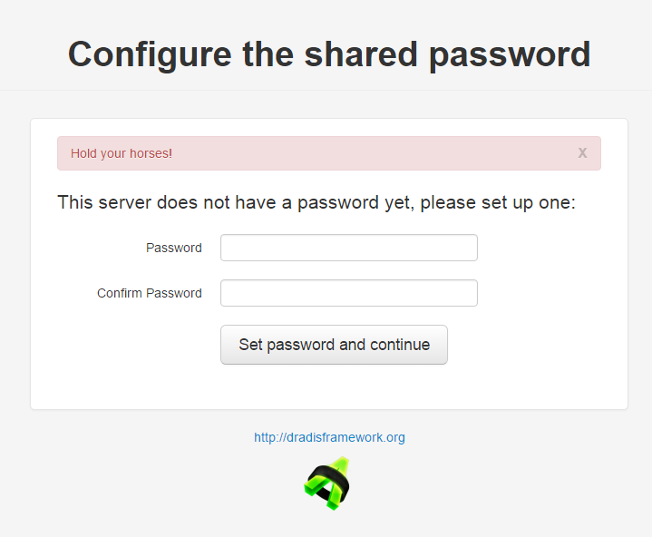

1. Create a username, then enter the password you created above:

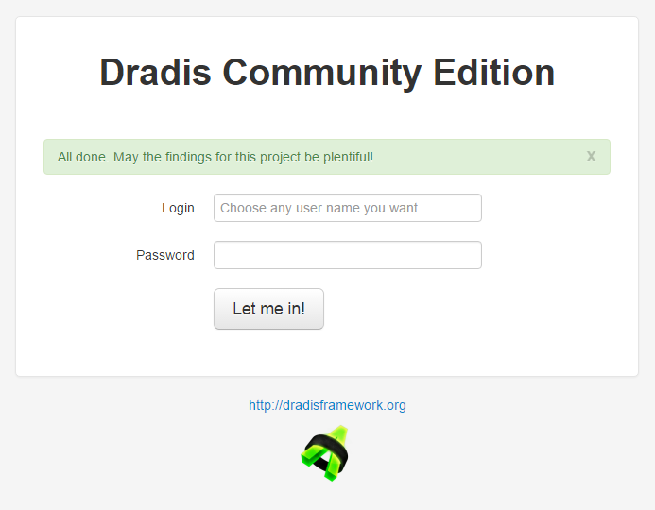

Congratulations!

You did it! You have now completed the installation process. Congratulations on making it all the way from git to running! Dradis CE will be installed with some sample issues, and a Methodology and some Nodes with instructions designed to familiarize you with Dradis features and functionality.

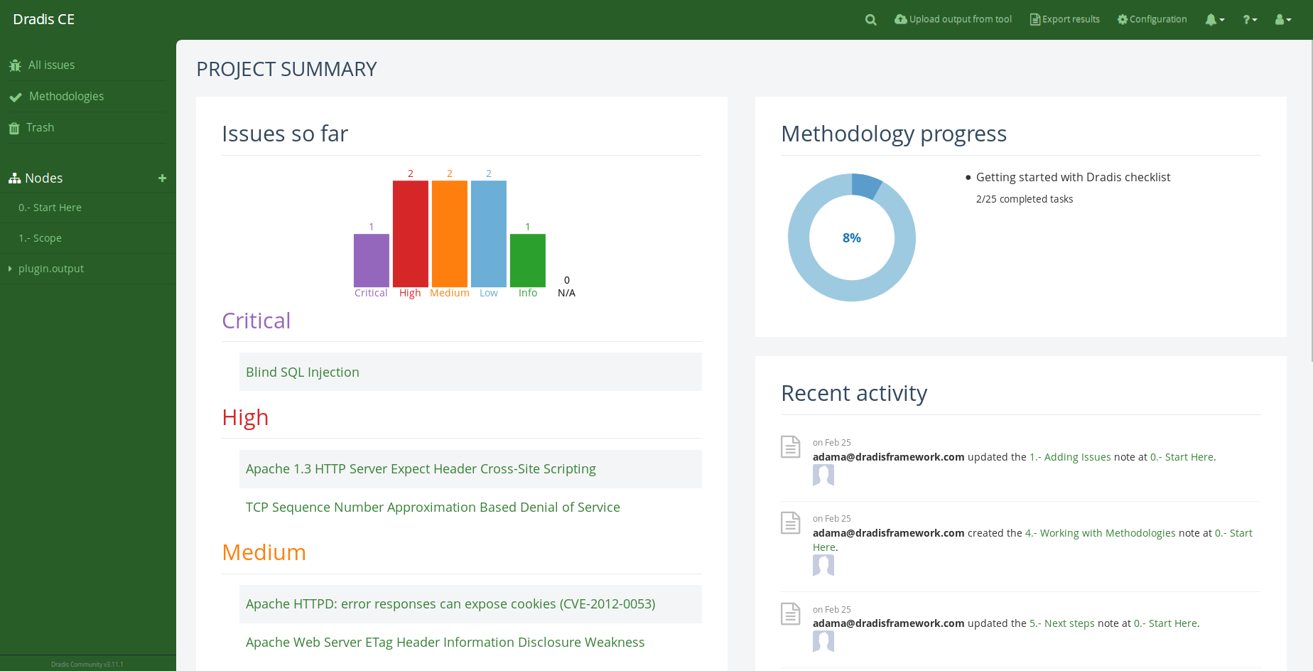

Troubleshooting tips

* **I'm installing on Kali Linux**: check out the [troubleshooting section](https://dradisframework.com/ce/documentation/install_kali.html#troubleshooting) of the Installing Dradis on Kali Linux guide.

* **The path '~/dradis-plugins' does not exist**:  
  First, check the file structure. Have you created any folders other than dradis-ce? If not, try running: $ ./bin/setup.  
  Did the download create a folder like **/community** that holds the **dradis-plugins** folder? If so, move the contents of the **community** folder out into the same file that holds the **dradis-ce** folder.

* **An error occurred while installing gem-name (1.0.0), and Bundler cannot continue**:  
  This is ikely a system-specific dependency issue. The first line of defense is to Google the specific error message to see whether StackOverflow or similar sites offer a solution. If you cannot resolve the issue, let us know in the [Community Forums](https://discuss.dradisframework.org/)

* **ActionController::UrlGenerationError in HomeController#index  
  No route matches {:action=>"init", :controller=>"home"}**: If you see this error(pictured below) when you navigate to Dradis, go to /setup in your browser to force Dradis to start the setup process.

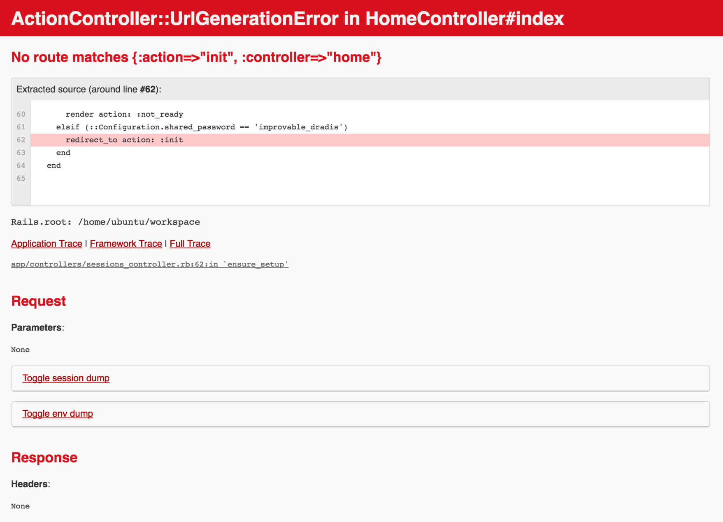

Next? Check out [the rest of the Dradis Community guides](https://dradisframework.com/ce/documentation/).